Alaska
Alaska Multiple Listing Service Inc.

Arkansas
Russellville Board of Realtors

Alabama
Blackbelt MLS
Lake Martin Area Association of Realtors
Talladega County MLS Inc.
Walker County Area MLS

Arizona
Central Arizona Board of Realtors
Prescott Area Assoc. of Realtors
Puerto Penasco MLS
Santa Cruz County MLS
Sedona Verde Valley Assoc. of Realtors
Southeast Arizona Multiple Listing Service

California
Coastal Mendocino MLS
Humboldt Assoc. of Realtors
South East Kern Board of Realtors

Colorado
Aspen Glenwood MLS
Grand County Board of Realtors
Spanish Peaks Board of Realtors
Tulluride Association of Realtors

Florida
Emerald Coast Navarre
Florida Keys MLS Inc.
Palm Beach Board of Realtors

Idaho
Sun Valley Board of Realtors

Illinois
West Central Illinois Assoc. of Regional

Iowa
Central Iowa Board of Realtors
Muscatine Board of Realtors
Southwest Iowa Assoc. of Realtors
Spirit Lake MLS

Indiana
Bedford Board of Realtors

Kentucky
Louisville Board of Realtors

Massachusetts
Berkshire County MLS

Michigan
Eastern Upper Peninsula MLS
Water Wonderland MLS
SWIMRIC

Minnesota
Boix De Soiux Area Board of Realtors
Greater Alexandria Area Association of Realtors
Lake County Association of Realtors
Lake Region Association of Realtors
Northwest - Minnesota MLS

Missouri
Columbia MO Board of Realtors
Northwest Multiple Listing Service
Randolph County Board of Realtors
Southern Missouri Regional MLS
St. Joseph Regional Association of Realtors

Montana
Bitterroot Valley Board of Realtors
Great Falls Association of Realtors
Havre Hi Line Board of Realtors

New Jersey
Monmouth Ocean MLS

New York
Staten Island Board of Realtors
Warren County Board of Realtors

North Carolina
Lumberton Board of Realtors

North Dakota
Badlands Board of Realtors
Fargo-Moorhead Assoc. of Realtors
Grand Forks Board of Realtors
Jamestown Board of Realtors
Williston Board of Realtors

Oregon
Clatsop Assoc. of Realtors MLS
Tillamook County Board of Realtors

Pennsylvania
Carbon County Association of Realtors
Central Susquehanna Valley BOR
Clearfield Jefferson MLS
Elk/Cameron Board of Realtors
Fayette Board of Realtors
Greater Hazelton Assoc. of Realtors
Greater Scranton Board of Realtors
Greater Wilkes Barre Assoc. of Realtors
Keystone MLS Network
Lakelands West MultiList
Lehigh Valley
Pike Wayne Association of Realtors
Pocono Mountains Assoc. of Realtors
West Branch Valley Association of Realtors

South Dakota
Aberdeen Multiple Listing Service
Huron Board of Realtors
Mitchell Board of Realtors
NESD Board of Realtors
Pierre Area MLS

Texas
Amarillo Assoc. of Realtors
Dumas Board of Realtors
Pampa Board of Realtors
Plainview Assoc. of Realtors

Utah
Iron County Board of Realtors
Washington County Board of Realtors

Virginia
New River Valley Association of Realtors
Williamsburg Multiple Listing Service

West Virginia
Greenbrier Valley Board of Realtors

Wisconsin
Marinette MLS

Wyoming
Sheridan Board of Realtors
Teton Board of Realtors

Spark Platform Instructions
- Log into the NextHome intranet
- Click on "Presentation Builder" QUICK LINK to launch CloudCMA
- Once in CloudCMA go to your "Settings" at the top right hand corner
- Select "MLS" once in your Settings
- Under the "MLS Provider" dropdown select "Spark Platform" under "Other" at the very bottom of the MLS Provider list
- Input your username and password for your MLS below
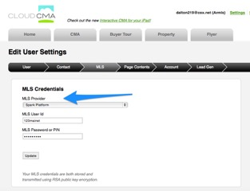

Then click on the CMA Tab inside CloudCMA to begin creating a new CMA.

A pop up from spark will appear to confirm your MLS and authentic for Spark:

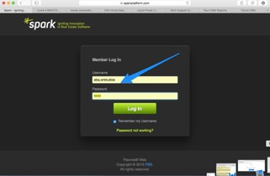

You would enter the name of the client and the address of the subject property along with the rest of the report information.

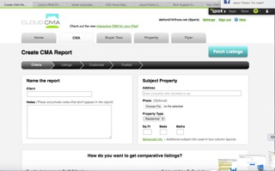

Then follow the prompts to create your CMA.

